Name: Sandesh Varma Date: 21/07/2025

Roll No: CH.EN.U4CSE22078

Experiment No: 1

___________________________________________________________________________________

Aim: To implement Lexical Analyzer Using Lex Tool

Code:

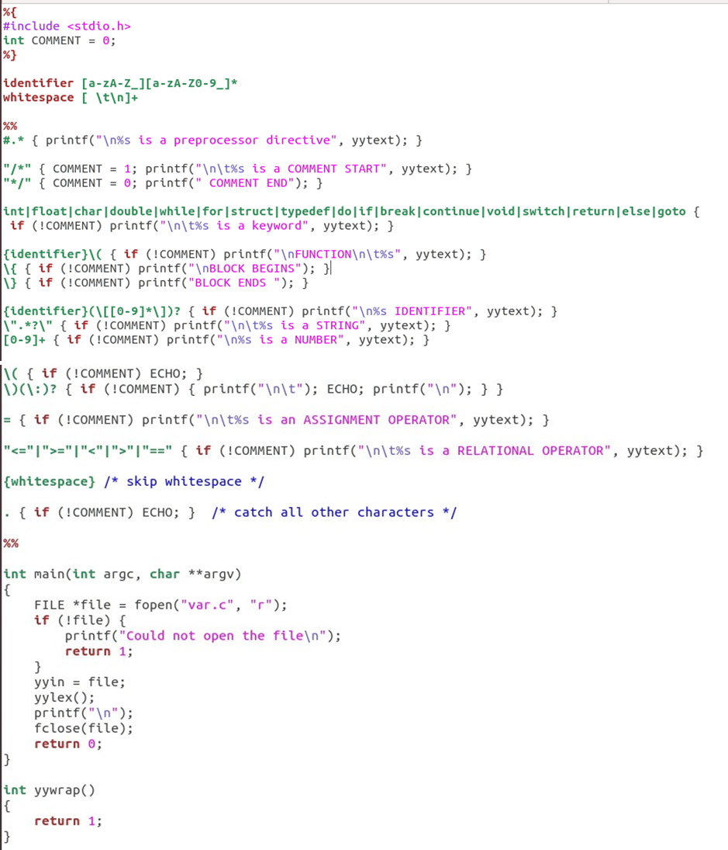

Name: Sandesh Varma

Roll No: CH.EN.U4CSE22078

**Variable.c**

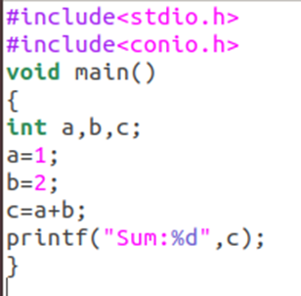

Output:

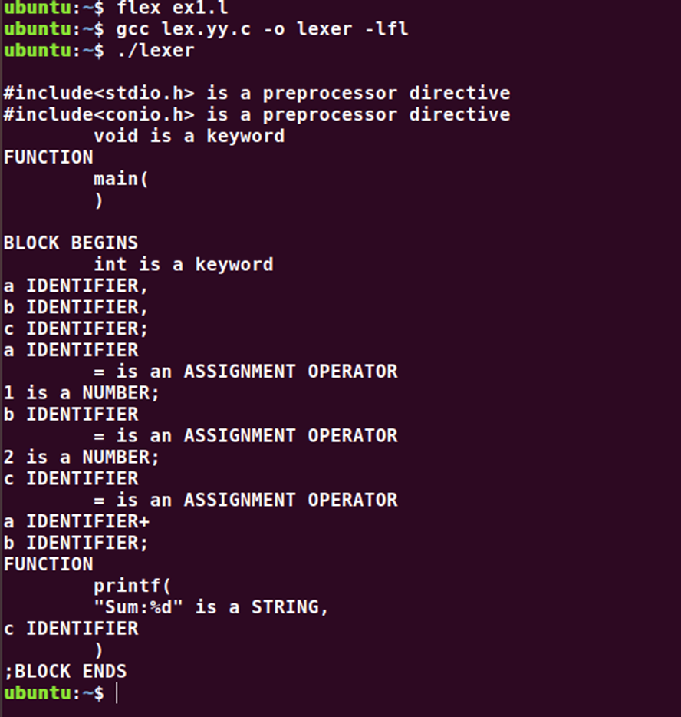

Result: The code has been executed and output displayed successfully.